**Name: Adithya M SRN: PES1UG20CS621 Section: K**

**Lab Quiz**

1. SELECT DISTINCT COURSE.CourseName

FROM COURSE,SECTION

WHERE COURSE.CourseNumber=SECTION.CourseNumber

AND SECTION.Year BETWEEN 2001 AND 2004;

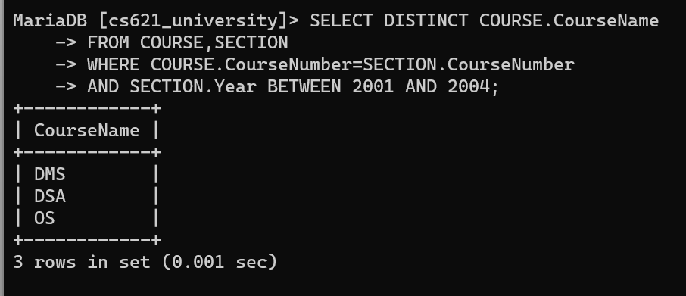

1. CREATE TABLE Student_Report (

StudentNumber int not null,

SectionIdentifier int not null,

marks int,

PRIMARY KEY(StudentNumber, SectionIdentifier),

FOREIGN KEY(StudentNumber) REFERENCES STUDENT(StudentNumber),

FOREIGN KEY(SectionIdentifier) REFERENCES SECTION(SectionIdentifier)

);

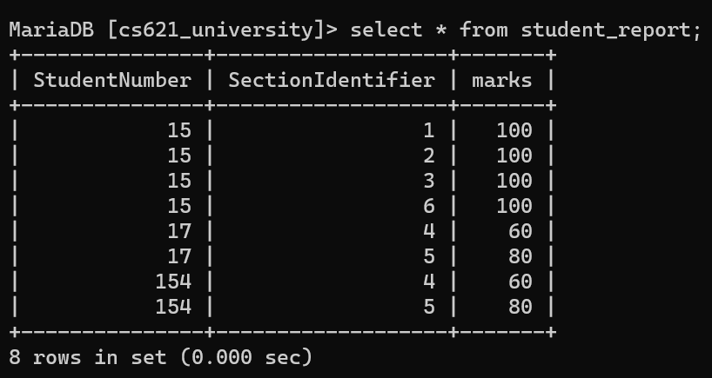

1. CREATE TABLE student_result (

StudentNumber int not null,

Totalmarks int

);

INSERT into student_result(StudentNumber, Totalmarks)

SELECT StudentNumber,

SUM(marks)

FROM Student_Report

GROUP BY StudentNumber;

DELIMITER $$

CREATE or REPLACE TRIGGER update_total_marks

AFTER INSERT ON Student_Report

FOR EACH ROW

BEGIN

UPDATE student_result

SET Totalmarks = Totalmarks + NEW.marks

WHERE StudentNumber = NEW.StudentNumber;

END;

$$

DELIMITER ;

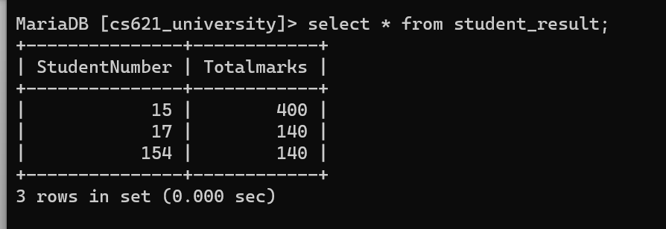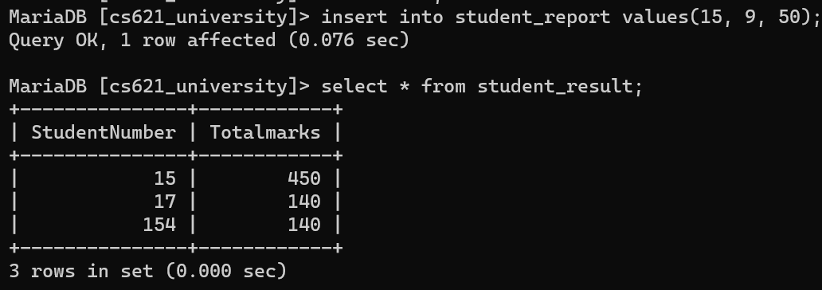

1. ALTER TABLE student_result

ADD Remarks varchar(30);

DELIMITER $$

CREATE function get_remarks(major varchar(4))

RETURNS varchar(30)

BEGIN

DECLARE remarks varchar(30);

IF major = 'CS' THEN

SET remarks = 'Computer Science Engg';

ELSEIF major = 'EC' THEN

SET remarks = 'Electronics Engg';

ELSE

SET remarks = 'Other';

END IF;

RETURN remarks;

END;

$$

DELIMITER ;

DELIMITER $$

CREATE or REPLACE TRIGGER update_remarks

AFTER INSERT ON STUDENT

FOR EACH ROW

BEGIN

UPDATE student_result

SET Remarks = get_remarks(NEW.Major)

WHERE StudentNumber = NEW.StudentNumber;

END;

$$

DELIMITER ;

INSERT INTO STUDENT

VALUES ('Adi', 18, 4, 'CS');

